DATBASE PROJECT MID EVALUATION

MEMBERS :-

SHARJEEL SAFDAR (22K4210)

SUHAIB SHAIKH (22K4302)

ER_DIAGRAM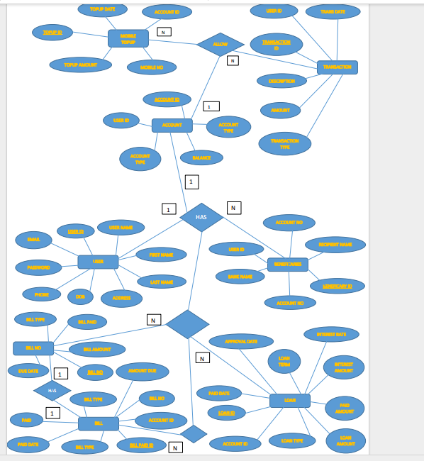

NORMALIZATION

1NF :-
ALL TABLES HAVE ATOMIC (INDIVISIBLE) VALUES IN EACH COLUMN.
THERE ARE NO REPEATING GROUPS OR ARRAYS.

2NF :-
ALL TABLES ARE IN 1NF.
THERE ARE NO PARTIAL DEPENDENCIES ON COMPOSITE PRIMARY KEYS.
NO NON-PRIME ATTRIBUTE IS DEPENDENT ON ONLY A PORTION OF THE PRIMARY KEY.

(3NF):-
ALL TABLES ARE IN 2NF.
THERE ARE NO TRANSITIVE DEPENDENCIES.
NO NON-PRIME ATTRIBUTE IS DEPENDENT ON ANOTHER NON-PRIME ATTRIBUTE.

(BCNF):-
ALL TABLES ARE IN 3NF.
THERE ARE NO NON-TRIVIAL FUNCTIONAL DEPENDENCIES OF ATTRIBUTES ON SUPERKEYS.

